Oh My Genes Documentation

**Mohamed Jifry Hazzaly Mohamed**

**20173212016**

**Software Engineering 2017**

**March 03, 2019**

Table of Contents

1. Introduction 3

1.1. Introduction 3

1.2. Purpose 3

1.3. Overview 3

1.4. User characteristics 4

2. Functional Requirements 5

2.1. Inputs 5

2.2. Output 6

2.2.1. Table 6

2.2.2. Scatter plot 6

3. Non Functional Requirements 7

3.1. Response Time 7

3.2. Aesthetic Aspects 7

3.3. Confidentiality policy 7

4. Constraints 8

4.1. Browser Compatibility 8

4.2. Space Complexity 8

4.3. Budget 8

4.4. System Downtime 8

5. Change Cases 9

6. Milestone 10

7. Appendices 11

8. References 12

9. Group Information 13

9.1 Group Name 13

9.2 Done By 13

# 1. Introduction

## 1.1. Introduction

This report explains the initial requirements for an online application (Oh My Genes).

## 1.2. Purpose

The purpose of this web application to compare the two samples and identify different performance between the same genes from given a gene expression file holding two cell samples automatically and quickly. But the main intention is to support biologists to analyze their experimental data.

## 1.3. Overview

To analyze the differentially expressed genes this web application based on flask framework.

This web application's interface is a simplistic one. It contains only one button that is [Upload and Go]. Our biologist can upload a plain text file holding gene expression levels from two samples, representing two experimental statuses. The application Receive the file and return a table of difference between genes and a scatter plot. The scatter plot's X-axis is control and Y-axis is treatment.

If he uploads invalid gene expression file like different column sizes or heading missing or file is other than text format, the web application will return an error message and inform the user to provide the correct format.

## 1.4. User characteristics

User: - Biologists, scientists, researchers and others who dedicate themselves study the expression of genes.

Maintainer: - Who have the basic knowledge of flask and python to maintain a website like Students, professionals, specialist, Technicians.

# 2. Functional Requirements

## 2.1. Inputs

A valid gene expression file must be the following format.

It’s TAB-delimited, plain text file with three columns.

The file contains an optional head line, followed by each gene’s

expression in a control sample (e.g., ControlSample) and in a treatment sample (e.g., KnockOutSample).

See the txt file pattern as following:-

gene_id ControlSample KnockOutSample

AT1G01010 1.198558083 2.036161827

AT1G01020 13.75736234 13.370796

AT1G01030 0.833779536 0.203616183

AT1G01040 9.58846466 7.126566394

AT1G01046 0 0

AT1G01050 23.81482799 21.10821094

AT1G01060 0.625334652 1.221697096

AT1G01070 1.719670292 0.950208853

AT1G01080 28.34850421 25.24840665

AT1G01110 2.709783491 1.425313279

## 2.2. Output

### 2.2.1. Table

### Capture.JPG

### 2.2.2. Scatter plot

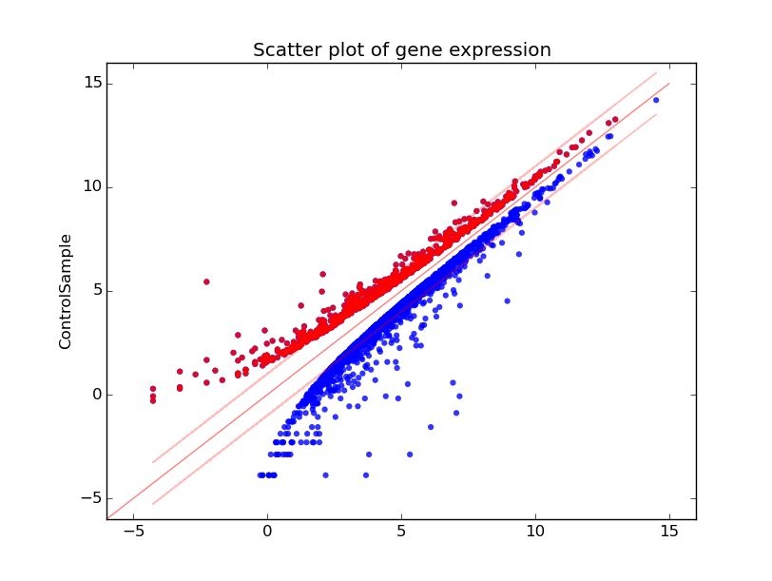

# 3. Non Functional Requirements

* This part we going to explain some non-functional requirements.
* Non-functional requirements include response time, Aesthetic aspects and confidentiality policy.

## 3.1. Response Time

Response time must be less than 5 seconds for any case.

## 3.2. Aesthetic Aspects

The aspects of this application are user-friendly and human-computer an interaction. The main purpose is to generate a powerful website where the client can get wanted parts of information quickly and efficiently without being a delay.

## 3.3. Confidentiality policy

NEVER use the saved results to seek any profits or benefits. And it’s ok to receive the result without sign in.

# 4. Constraints

## 4.1. Browser Compatibility

To satisfy multiple clients, its Accessible through Firefox, Chrome, and Safari.

## 4.2. Space Complexity

Web space must be less than 1GB. So it will run much faster.

## 4.3. Budget

The most significant is the Budget. The fewer funds we use, the better we hope. So budget no more than 10,000 USD.

## 4.4. System Downtime

We need to use this software to support our analysis the whole year, and we hope that the software does mistakes or shut down accidentally very less, our team want the downtime of the system is less than 30 minutes per year.

# 5. Change Cases

* Instead of support only text files maybe can support Excel files also.
* Improve the processing time.
* Develop application appearance.

(To Be Added….)

# 6. Milestone

1. Submit SRS for review by March 27th.

2. Get SRS approved by May 8th.

3. Get design done by May 10th.

4. Get coding done by May 15th.

5. Acceptance tests by June 1st.

6. Release by June 06th.

# 7. Appendices

1. Control sample - a cell sample prepared in its normal condition.

2. Treatment sample - a cell sample treated by special chemicals, or in which some genes are altered.

3. Differentially expressed genes - the genes which have significantly different expression levels between two

samples.

6. Change cases- are developments that might

happen in the future.

# 8. References

* SRS example - <https://oh-my-genes.readthedocs.io/en/latest/>
* D:\class\SoftwareEngineering foundation\oh-my-genes.pdf

# 9. Group Information

## 9.1 Group Name

One man Army

## 9.2 Done By

Mohamed Jifry Hazzaly Mohamed – (201732120165) – mohamedsukri11@hotmail.com